**Data types in java :** https://www.tutorialspoint.com/java/java_basic_datatypes.htm

There is a special group of data types (also known as primitive types) that will be used quite often in programming. The primitive types are also commonly referred to as simple types which can be put in four groups :

* **Integers:** This group includes **byte, short, int, and long**, which are for whole-valued signed numbers.
* **Floating-point numbers:**This group includes **float and double**, which represent numbers with fractional precision.
* **Characters:**This group includes **char**, which represents symbols in a character set, like letters and numbers.
* **Boolean:** This group includes **boolean**, which is a special type for representing true/false values
  1. **Byte -**
* The smallest integer type is byte. It has a minimum value of -128 and a maximum value of 127 (inclusive). The byte data type can be useful for saving memory in large arrays, where the memory savings actually matters. EX.: byte b =100;

2. **short:**

It is used to store integers in the range **-32768 to 32767**. EX.: short s =123;

3. **int:**

The most commonly used integer type is int. We can use up to a 10 digit number with int type. EX.: int v = 123543; int calc = -9876345;

4. **long:**

When we want to store a value bigger than int range, we should use long type. With long, we can store up to a 19 digit number. EX.: long amountVal = 1234567891;

5. **float:**

To work with numbers with a fractional part, we can use float type. 32 bits of storage EX.: float intrestRate = 12.25f;

6. **double:**

A bigger type, uses 64 bits to store a value. EX. : double d = 12345.234d

double d1 = 123.4

7. **boolean:**

The boolean data type has only two possible values: true and false. Use this data type for simple flags that track true/false conditions. Ex.: boolean flag = true;

Boolean val = false;

8. **char:**

the data type used to store characters is char. Ex.: char P = 'Abcd';

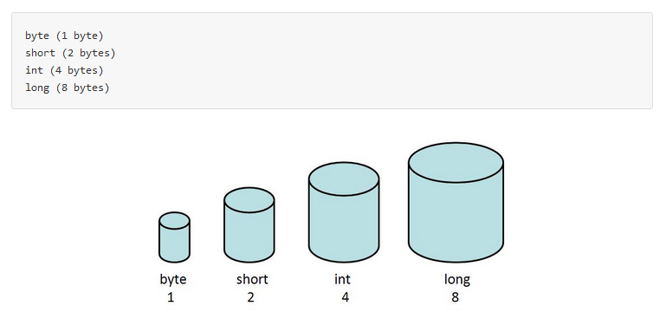

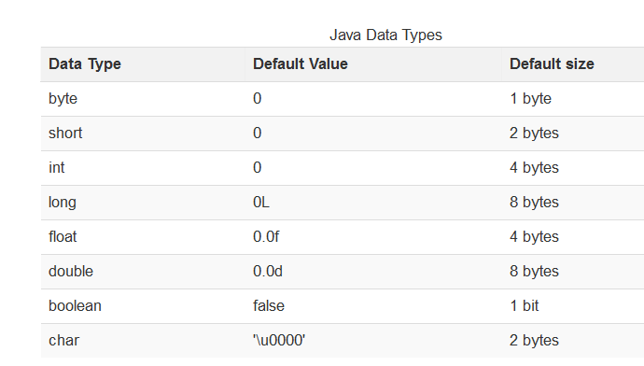1 Byte = 8 Bit.